**STATICS** ***UDM ENGR 3120*** - ***BUCT MEC 1701-1703*** ***CHAPTER 2 – Statics of Particles***

ASSIGNMENT # 1-3 Due on 9/12/19 Student # ………………. Name …………………………

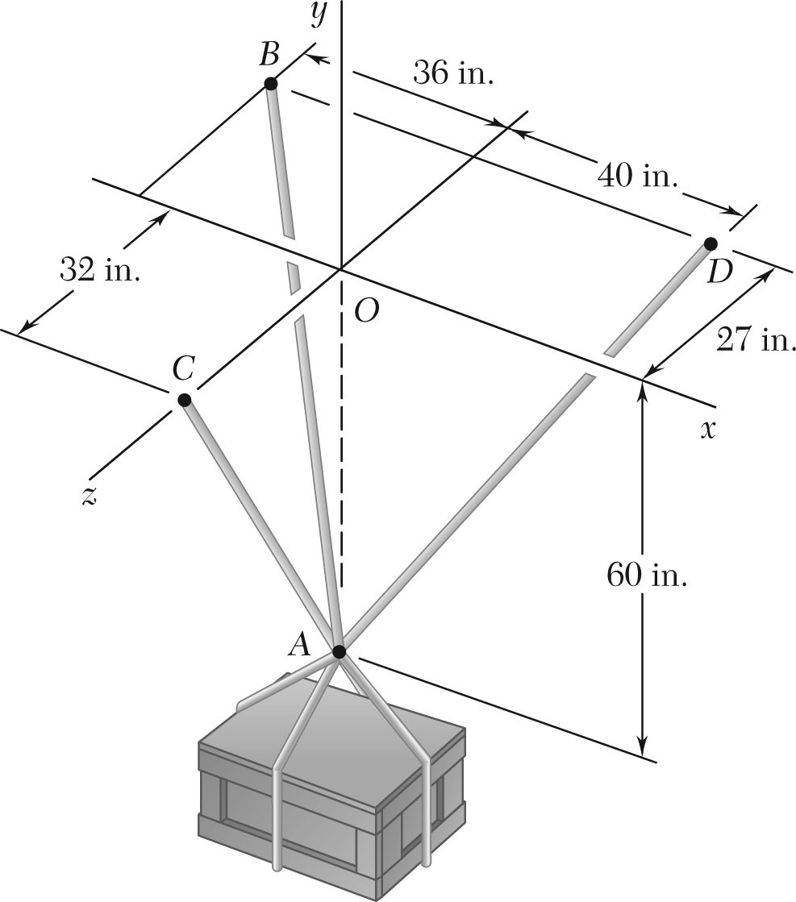

A crate is supported by three cables as shown.

1. Determine the weight of the crate knowing that the tension in cable *AB* is 750 lb.
2. Determine the weight of the crate knowing that the tension in cable *AD* is 616 lb.
3. Determine the weight of the crate knowing that the tension in cable *AC* is 544 lb.